### A) Die Pole eines Magneten

**der Magnet,-en** imán

**die Stelle,-n** lugar

**die Wirkung,-en** efecto

**die Kraft, ~~¨e~~** fuerza

**der Nagel, ~~¨~~** clavo

**das Joch** yugo

**hoch|heben** levantar

**befinden** encontrarse

Die Stellen eines Magneten mit der stärksten Kraftwirkung nennt man Pole des Magneten.

### Experimente

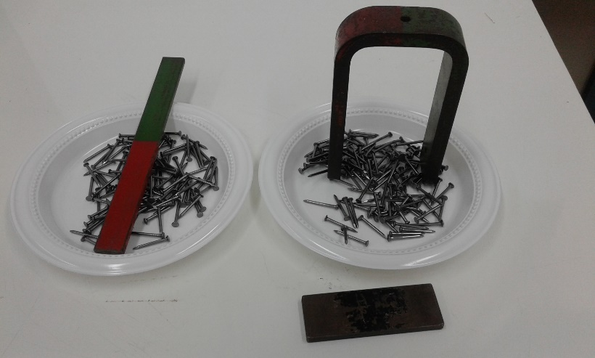• Lege den Stabmagneten auf die kleinen Eisennägel und hebe ihn dann hoch. Wo befinden sich die Pole dieses Magneten?

• Lege den Hufeisenmagneten (ohne das Joch aus Eisen) auf die kleinen Eisennägel und hebe ihn dann hoch. Wo befinden sich die Pole dieses Magneten?

**Zeichne und beschreibe das durchgeführte Experiment!**

|  |  |  |  |  |  |  |  |  |  |  |  |  |  |  |  |  |  |  |  |  |  |  |  |  |  |  |
| --- | --- | --- | --- | --- | --- | --- | --- | --- | --- | --- | --- | --- | --- | --- | --- | --- | --- | --- | --- | --- | --- | --- | --- | --- | --- | --- |
|  |  |  |  |  |  |  |  |  |  |  |  |  |  |  |  |  |  |  |  |  |  |  |  |  |  |  |
|  |  |  |  |  |  |  |  |  |  |  |  |  |  |  |  |  |  |  |  |  |  |  |  |  |  |  |
|  |  |  |  |  |  |  |  |  |  |  |  |  |  |  |  |  |  |  |  |  |  |  |  |  |  |  |
|  |  |  |  |  |  |  |  |  |  |  |  |  |  |  |  |  |  |  |  |  |  |  |  |  |  |  |
|  |  |  |  |  |  |  |  |  |  |  |  |  |  |  |  |  |  |  |  |  |  |  |  |  |  |  |
|  |  |  |  |  |  |  |  |  |  |  |  |  |  |  |  |  |  |  |  |  |  |  |  |  |  |  |
|  |  |  |  |  |  |  |  |  |  |  |  |  |  |  |  |  |  |  |  |  |  |  |  |  |  |  |
|  |  |  |  |  |  |  |  |  |  |  |  |  |  |  |  |  |  |  |  |  |  |  |  |  |  |  |
|  |  |  |  |  |  |  |  |  |  |  |  |  |  |  |  |  |  |  |  |  |  |  |  |  |  |  |
|  |  |  |  |  |  |  |  |  |  |  |  |  |  |  |  |  |  |  |  |  |  |  |  |  |  |  |
|  |  |  |  |  |  |  |  |  |  |  |  |  |  |  |  |  |  |  |  |  |  |  |  |  |  |  |
|  |  |  |  |  |  |  |  |  |  |  |  |  |  |  |  |  |  |  |  |  |  |  |  |  |  |  |
|  |  |  |  |  |  |  |  |  |  |  |  |  |  |  |  |  |  |  |  |  |  |  |  |  |  |  |
|  |  |  |  |  |  |  |  |  |  |  |  |  |  |  |  |  |  |  |  |  |  |  |  |  |  |  |
|  |  |  |  |  |  |  |  |  |  |  |  |  |  |  |  |  |  |  |  |  |  |  |  |  |  |  |
|  |  |  |  |  |  |  |  |  |  |  |  |  |  |  |  |  |  |  |  |  |  |  |  |  |  |  |
|  |  |  |  |  |  |  |  |  |  |  |  |  |  |  |  |  |  |  |  |  |  |  |  |  |  |  |
|  |  |  |  |  |  |  |  |  |  |  |  |  |  |  |  |  |  |  |  |  |  |  |  |  |  |  |
|  |  |  |  |  |  |  |  |  |  |  |  |  |  |  |  |  |  |  |  |  |  |  |  |  |  |  |
|  |  |  |  |  |  |  |  |  |  |  |  |  |  |  |  |  |  |  |  |  |  |  |  |  |  |  |

die Nägel; der Pol, e; die Enden

hängenbleiben, kleben, sich befinden, eine Kette bilden

am stärksten sein ,die meisten Nägel, die größten magnetische Kräfte

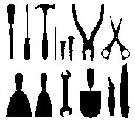

# B) Wer zieht wen an? Die magnetische Kraftwirkung

### Experiment

**der Wagen, -** *hier:*carrito

**jeweils** en cada caso?

**das Rad,~~¨~~er** rueda

**beweglich** movible

**gegenseitig** mutuamente

In zwei Wagen liegen jeweils ein Stabmagnet und ein Eisenstab.

Probiere aus, welcher Wagen welchen anzieht.

Eventuell sind die Räder von den beiden Wagen unterschiedlich gut beweglich. Tausche deshalb die Wagen aus, so dass der Magnet und der Eisenstab jeweils in einem anderen Wagen liegen. 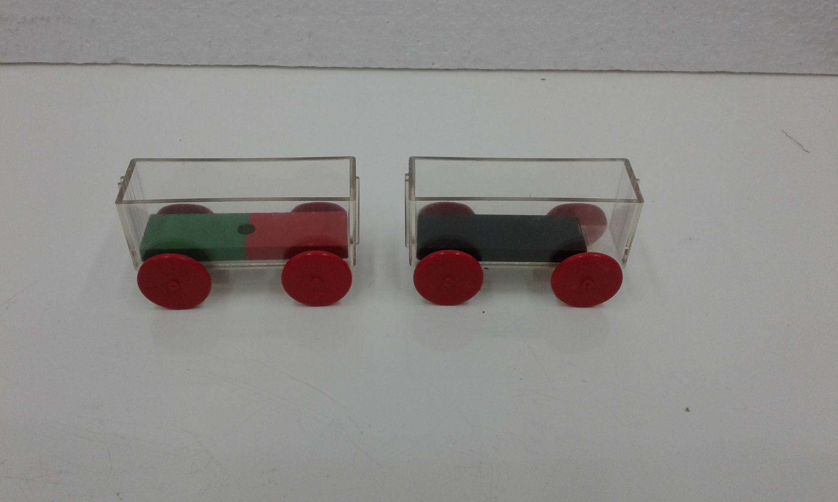

**Beschreibe deine Beobachtungen:**

|  |  |  |  |  |  |  |  |  |  |  |  |  |  |  |  |  |  |  |  |  |  |  |  |  |  |  |
| --- | --- | --- | --- | --- | --- | --- | --- | --- | --- | --- | --- | --- | --- | --- | --- | --- | --- | --- | --- | --- | --- | --- | --- | --- | --- | --- |
|  |  |  |  |  |  |  |  |  |  |  |  |  |  |  |  |  |  |  |  |  |  |  |  |  |  |  |
|  |  |  |  |  |  |  |  |  |  |  |  |  |  |  |  |  |  |  |  |  |  |  |  |  |  |  |
|  |  |  |  |  |  |  |  |  |  |  |  |  |  |  |  |  |  |  |  |  |  |  |  |  |  |  |
|  |  |  |  |  |  |  |  |  |  |  |  |  |  |  |  |  |  |  |  |  |  |  |  |  |  |  |
|  |  |  |  |  |  |  |  |  |  |  |  |  |  |  |  |  |  |  |  |  |  |  |  |  |  |  |
|  |  |  |  |  |  |  |  |  |  |  |  |  |  |  |  |  |  |  |  |  |  |  |  |  |  |  |
|  |  |  |  |  |  |  |  |  |  |  |  |  |  |  |  |  |  |  |  |  |  |  |  |  |  |  |
|  |  |  |  |  |  |  |  |  |  |  |  |  |  |  |  |  |  |  |  |  |  |  |  |  |  |  |
|  |  |  |  |  |  |  |  |  |  |  |  |  |  |  |  |  |  |  |  |  |  |  |  |  |  |  |
|  |  |  |  |  |  |  |  |  |  |  |  |  |  |  |  |  |  |  |  |  |  |  |  |  |  |  |
|  |  |  |  |  |  |  |  |  |  |  |  |  |  |  |  |  |  |  |  |  |  |  |  |  |  |  |
|  |  |  |  |  |  |  |  |  |  |  |  |  |  |  |  |  |  |  |  |  |  |  |  |  |  |  |
|  |  |  |  |  |  |  |  |  |  |  |  |  |  |  |  |  |  |  |  |  |  |  |  |  |  |  |
|  |  |  |  |  |  |  |  |  |  |  |  |  |  |  |  |  |  |  |  |  |  |  |  |  |  |  |
|  |  |  |  |  |  |  |  |  |  |  |  |  |  |  |  |  |  |  |  |  |  |  |  |  |  |  |
|  |  |  |  |  |  |  |  |  |  |  |  |  |  |  |  |  |  |  |  |  |  |  |  |  |  |  |
|  |  |  |  |  |  |  |  |  |  |  |  |  |  |  |  |  |  |  |  |  |  |  |  |  |  |  |
|  |  |  |  |  |  |  |  |  |  |  |  |  |  |  |  |  |  |  |  |  |  |  |  |  |  |  |

das Eisenstück; der Stabmagnet; der Wagen

sich anziehen; sich aufeinander zubewegen; rollen

beide; gegenseitig; keine Rolle spielen



# C) Der stehende Nagel

Ein Nagel steht aufrecht unter dem Einfluss eines eingespannten Magneten. Sein Südpol weist zum Kopf des Nagels.

Wird dem Nagelkopf der Nordpol eines weiteren Magneten genähert, so fällt dieser um.

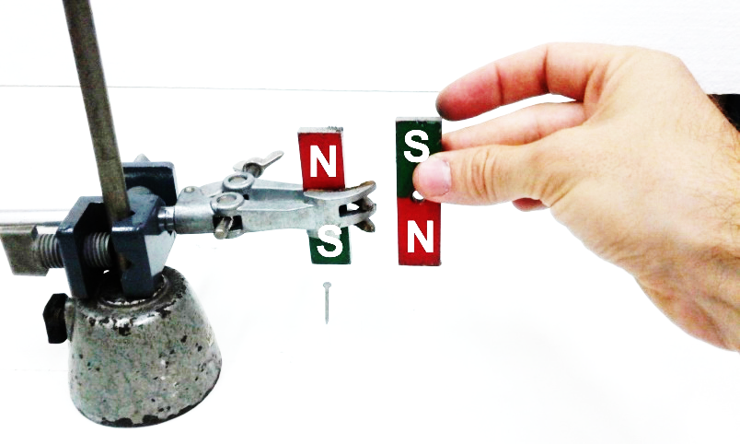

**aufrecht** derecho

**der Einfluss, ~~¨~~e** influecia

**weisen** señalar?

**nähern** acercar

**um|fallen** caerse

**einspannen** fijar, sujetar

**Versuche dieses Phänomen zu erklären.**

|  |  |  |  |  |  |  |  |  |  |  |  |  |  |  |  |  |  |  |  |  |  |  |  |  |  |  |
| --- | --- | --- | --- | --- | --- | --- | --- | --- | --- | --- | --- | --- | --- | --- | --- | --- | --- | --- | --- | --- | --- | --- | --- | --- | --- | --- |
|  |  |  |  |  |  |  |  |  |  |  |  |  |  |  |  |  |  |  |  |  |  |  |  |  |  |  |
|  |  |  |  |  |  |  |  |  |  |  |  |  |  |  |  |  |  |  |  |  |  |  |  |  |  |  |
|  |  |  |  |  |  |  |  |  |  |  |  |  |  |  |  |  |  |  |  |  |  |  |  |  |  |  |
|  |  |  |  |  |  |  |  |  |  |  |  |  |  |  |  |  |  |  |  |  |  |  |  |  |  |  |
|  |  |  |  |  |  |  |  |  |  |  |  |  |  |  |  |  |  |  |  |  |  |  |  |  |  |  |
|  |  |  |  |  |  |  |  |  |  |  |  |  |  |  |  |  |  |  |  |  |  |  |  |  |  |  |
|  |  |  |  |  |  |  |  |  |  |  |  |  |  |  |  |  |  |  |  |  |  |  |  |  |  |  |
|  |  |  |  |  |  |  |  |  |  |  |  |  |  |  |  |  |  |  |  |  |  |  |  |  |  |  |
|  |  |  |  |  |  |  |  |  |  |  |  |  |  |  |  |  |  |  |  |  |  |  |  |  |  |  |
|  |  |  |  |  |  |  |  |  |  |  |  |  |  |  |  |  |  |  |  |  |  |  |  |  |  |  |
|  |  |  |  |  |  |  |  |  |  |  |  |  |  |  |  |  |  |  |  |  |  |  |  |  |  |  |
|  |  |  |  |  |  |  |  |  |  |  |  |  |  |  |  |  |  |  |  |  |  |  |  |  |  |  |
|  |  |  |  |  |  |  |  |  |  |  |  |  |  |  |  |  |  |  |  |  |  |  |  |  |  |  |
|  |  |  |  |  |  |  |  |  |  |  |  |  |  |  |  |  |  |  |  |  |  |  |  |  |  |  |
|  |  |  |  |  |  |  |  |  |  |  |  |  |  |  |  |  |  |  |  |  |  |  |  |  |  |  |
|  |  |  |  |  |  |  |  |  |  |  |  |  |  |  |  |  |  |  |  |  |  |  |  |  |  |  |
|  |  |  |  |  |  |  |  |  |  |  |  |  |  |  |  |  |  |  |  |  |  |  |  |  |  |  |

der eingespannte Magnet; der angenäherte Magnet; die umgekehrte Pol

sich abschwächen; die magnetische Kraft reduzieren;

dadurch, dass; weil; aufgrund; als Folge hieraus



# D) Welche Metalle zieht ein Magnet an?

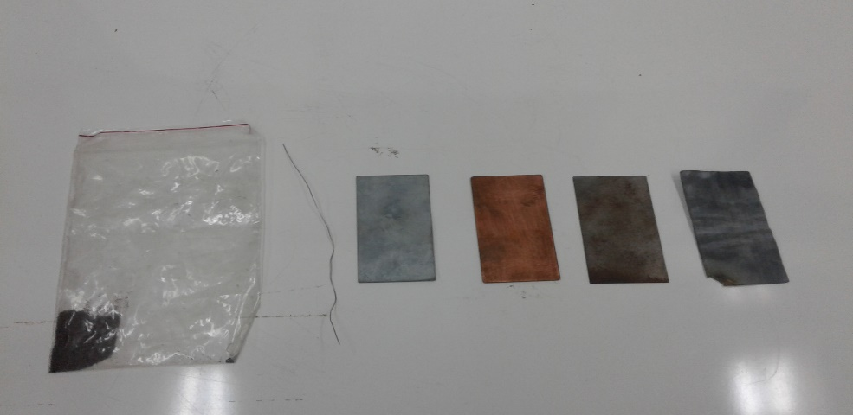

Welche Metalle werden von Magneten angezogen?

**vorliegend** presente

**das Blei** plomo

**das Eisen** hierro

**das Kupfer** cobre

**nähern** acercar

**um|fallen** caerse

**der Draht~~¨~~e** alambre

**die Tüte**,-n bolsa

Untersuche die vorliegenden Stoffe:

- Blei (Metallplatte mit der Aufschrift „Pb“)

- Eisen (Metallplatte ohne Aufschrift)

- Kupfer (Metallplatte mit Aufschrift „Cu“)

- Zinn (Metallplatte mit Aufschrift „Zn“)

- Nickel (Drahtstück)

- Kobalt (Tüte, bitte nicht öffnen!)

Die Metalle, die von Magneten angezogen werden, bezeichnet man als *ferromagnetisch.*

**Erstelle eine Tabelle, welche Metalle ferromagnetisch sind und welche nicht ferromagnetisch sind.**

|  |  |  |  |  |  |  |  |  |  |  |  |  |  |  |  |  |  |  |  |  |  |  |  |  |  |  |
| --- | --- | --- | --- | --- | --- | --- | --- | --- | --- | --- | --- | --- | --- | --- | --- | --- | --- | --- | --- | --- | --- | --- | --- | --- | --- | --- |
|  |  |  |  |  |  |  |  |  |  |  |  |  |  |  |  |  |  |  |  |  |  |  |  |  |  |  |
|  |  |  |  |  |  |  |  |  |  |  |  |  |  |  |  |  |  |  |  |  |  |  |  |  |  |  |
|  |  |  |  |  |  |  |  |  |  |  |  |  |  |  |  |  |  |  |  |  |  |  |  |  |  |  |
|  |  |  |  |  |  |  |  |  |  |  |  |  |  |  |  |  |  |  |  |  |  |  |  |  |  |  |
|  |  |  |  |  |  |  |  |  |  |  |  |  |  |  |  |  |  |  |  |  |  |  |  |  |  |  |
|  |  |  |  |  |  |  |  |  |  |  |  |  |  |  |  |  |  |  |  |  |  |  |  |  |  |  |
|  |  |  |  |  |  |  |  |  |  |  |  |  |  |  |  |  |  |  |  |  |  |  |  |  |  |  |
|  |  |  |  |  |  |  |  |  |  |  |  |  |  |  |  |  |  |  |  |  |  |  |  |  |  |  |
|  |  |  |  |  |  |  |  |  |  |  |  |  |  |  |  |  |  |  |  |  |  |  |  |  |  |  |
|  |  |  |  |  |  |  |  |  |  |  |  |  |  |  |  |  |  |  |  |  |  |  |  |  |  |  |
|  |  |  |  |  |  |  |  |  |  |  |  |  |  |  |  |  |  |  |  |  |  |  |  |  |  |  |
|  |  |  |  |  |  |  |  |  |  |  |  |  |  |  |  |  |  |  |  |  |  |  |  |  |  |  |
|  |  |  |  |  |  |  |  |  |  |  |  |  |  |  |  |  |  |  |  |  |  |  |  |  |  |  |
|  |  |  |  |  |  |  |  |  |  |  |  |  |  |  |  |  |  |  |  |  |  |  |  |  |  |  |
|  |  |  |  |  |  |  |  |  |  |  |  |  |  |  |  |  |  |  |  |  |  |  |  |  |  |  |
|  |  |  |  |  |  |  |  |  |  |  |  |  |  |  |  |  |  |  |  |  |  |  |  |  |  |  |
|  |  |  |  |  |  |  |  |  |  |  |  |  |  |  |  |  |  |  |  |  |  |  |  |  |  |  |
|  |  |  |  |  |  |  |  |  |  |  |  |  |  |  |  |  |  |  |  |  |  |  |  |  |  |  |
|  |  |  |  |  |  |  |  |  |  |  |  |  |  |  |  |  |  |  |  |  |  |  |  |  |  |  |
|  |  |  |  |  |  |  |  |  |  |  |  |  |  |  |  |  |  |  |  |  |  |  |  |  |  |  |

# E) Der zerbrochene Magnet

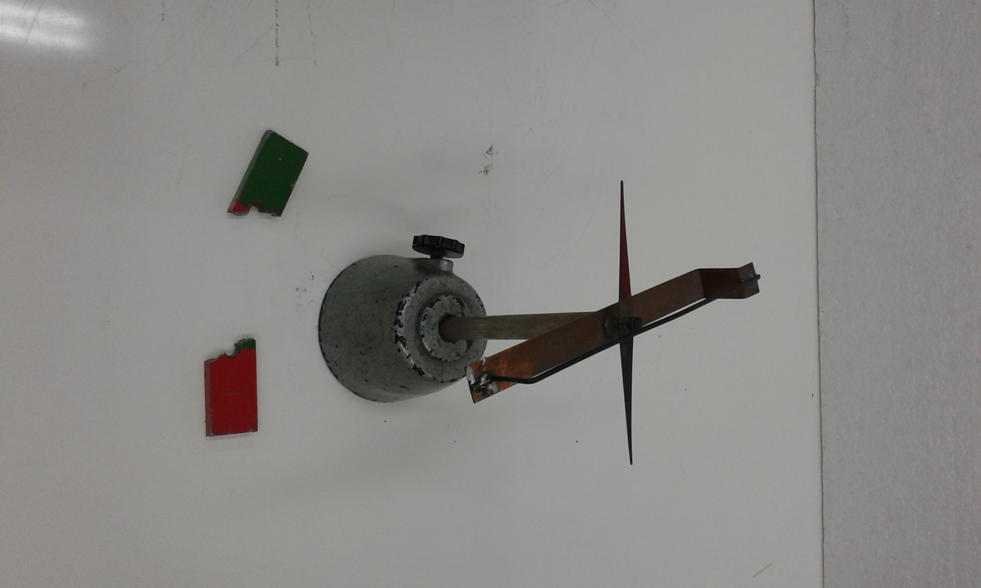

Ein Magnet ist heruntergefallen und in zwei Teile zerbrochen. Es sieht so aus, als habe man die beiden Pole getrennt.

Überprüfe mithilfe der Kompassnadel, ob der rote Teil nur aus einem Südpol besteht und der grüne Teil ausschließlich ein Nordpol ist.

**zerbrechen, zerbrochen** romper, quebrar

**herunterfallen** caerse

**trennen** separar

**überprüfen** examinar, revisar

**mithilfe** con ayuda de

**ausschließlich** exclusivamente

**Beschreibe deine Beobachtungen:**

|  |  |  |  |  |  |  |  |  |  |  |  |  |  |  |  |  |  |  |  |  |  |  |  |  |  |  |
| --- | --- | --- | --- | --- | --- | --- | --- | --- | --- | --- | --- | --- | --- | --- | --- | --- | --- | --- | --- | --- | --- | --- | --- | --- | --- | --- |
|  |  |  |  |  |  |  |  |  |  |  |  |  |  |  |  |  |  |  |  |  |  |  |  |  |  |  |
|  |  |  |  |  |  |  |  |  |  |  |  |  |  |  |  |  |  |  |  |  |  |  |  |  |  |  |
|  |  |  |  |  |  |  |  |  |  |  |  |  |  |  |  |  |  |  |  |  |  |  |  |  |  |  |
|  |  |  |  |  |  |  |  |  |  |  |  |  |  |  |  |  |  |  |  |  |  |  |  |  |  |  |
|  |  |  |  |  |  |  |  |  |  |  |  |  |  |  |  |  |  |  |  |  |  |  |  |  |  |  |
|  |  |  |  |  |  |  |  |  |  |  |  |  |  |  |  |  |  |  |  |  |  |  |  |  |  |  |
|  |  |  |  |  |  |  |  |  |  |  |  |  |  |  |  |  |  |  |  |  |  |  |  |  |  |  |
|  |  |  |  |  |  |  |  |  |  |  |  |  |  |  |  |  |  |  |  |  |  |  |  |  |  |  |
|  |  |  |  |  |  |  |  |  |  |  |  |  |  |  |  |  |  |  |  |  |  |  |  |  |  |  |
|  |  |  |  |  |  |  |  |  |  |  |  |  |  |  |  |  |  |  |  |  |  |  |  |  |  |  |
|  |  |  |  |  |  |  |  |  |  |  |  |  |  |  |  |  |  |  |  |  |  |  |  |  |  |  |
|  |  |  |  |  |  |  |  |  |  |  |  |  |  |  |  |  |  |  |  |  |  |  |  |  |  |  |
|  |  |  |  |  |  |  |  |  |  |  |  |  |  |  |  |  |  |  |  |  |  |  |  |  |  |  |
|  |  |  |  |  |  |  |  |  |  |  |  |  |  |  |  |  |  |  |  |  |  |  |  |  |  |  |
|  |  |  |  |  |  |  |  |  |  |  |  |  |  |  |  |  |  |  |  |  |  |  |  |  |  |  |
|  |  |  |  |  |  |  |  |  |  |  |  |  |  |  |  |  |  |  |  |  |  |  |  |  |  |  |
|  |  |  |  |  |  |  |  |  |  |  |  |  |  |  |  |  |  |  |  |  |  |  |  |  |  |  |
|  |  |  |  |  |  |  |  |  |  |  |  |  |  |  |  |  |  |  |  |  |  |  |  |  |  |  |
|  |  |  |  |  |  |  |  |  |  |  |  |  |  |  |  |  |  |  |  |  |  |  |  |  |  |  |
|  |  |  |  |  |  |  |  |  |  |  |  |  |  |  |  |  |  |  |  |  |  |  |  |  |  |  |
|  |  |  |  |  |  |  |  |  |  |  |  |  |  |  |  |  |  |  |  |  |  |  |  |  |  |  |
|  |  |  |  |  |  |  |  |  |  |  |  |  |  |  |  |  |  |  |  |  |  |  |  |  |  |  |

der Magnet; das Teil,-e; an der einen Seite, an der anderen Seite; das Bruchstück

geteilt sein; besitzen; anziehen;

trotzdem; obwohl; ganz gleich, ob man…; überraschenderweise

